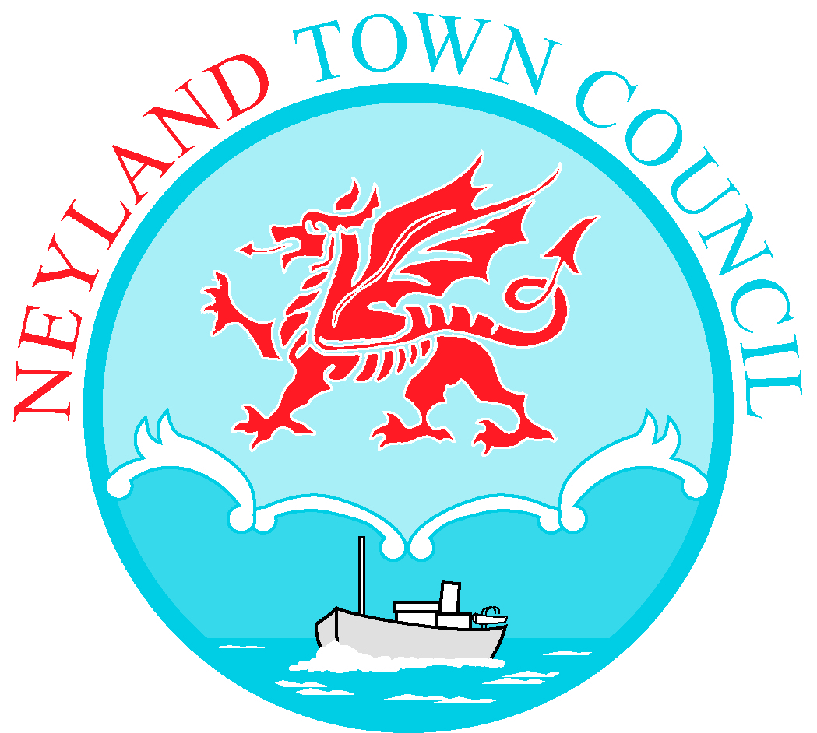

TO: All Members of Neyland Town Council 30th August 2023

Dear Councillor,

You are hereby summoned to attend an Ordinary Meeting of Neyland Town Council to be held on Monday 4th September, at 7.00pm at Neyland Community Hub. If you require a link to attend the meeting virtually, please email townclerk@neyland.org.uk

Yours sincerely,

Libby Matthews
Town Clerk/RFO

AGENDA
- To receive apologies for absence.
- To receive Declarations of Interest from Members regarding the business to be transacted.
- Representation by public (limited to 15 minutes)
- To approve minutes of Ordinary Meeting of Council 03.07.2023.
- To approve minutes from Extraordinary Meeting of Councillors held 07.08.2023.
- Discussion of Internal Audit
- Arrangements for the Fireworks display
- Arrangements for Remembrance Sunday
- Planning Application received for 71 High Street, Neyland
- Red Phone Box Adoption and Re-purposing
- Street/Boy Racers and Reporting them.
- 20 MPH speed limit introduction – reminder
- Town Council’s Electoral Boundaries
- Community Cohesion small grant application, International Day of Disability
- Discussion of donation to Cruising Free 2025
- Applying for Pembrokeshire Enhancement Funding – Cllr D Devauden
- Discussion on adopting an accounting package to manage finances.
- Payments to be approved.
- Clerk’s report.
- Mayor’s update.
- Deputy Mayor’s update.
- Exchange of information at the discretion of the Mayor.
- Date of next meeting:

